**Monsanto Dicamba Volatility Low-Tunnel 3**

(2018_Mon_Vol_03)

Dr. Rodrigo Werle

Dr. Maxwel Coura Oliveira

Ryan DeWerff

Nikola Arsenijevic

Sarah Striegel

Victor Hugo Vidal Ribeiro

Rachel Renz

August

2018

**Methods**

* *Soybean variety:* NK S25-L9 soybeans
* *Soybean seed rate:* 140,000 seeds acre-1
* *Soybean row width:* 30-inch rows at 1.5 in depth
* *Soybean planting:* 5/26/18
* *PRE-herbicide:* Warrant (48 fl. oz acre-1) + Tricor (0.33 lbs acre-1)
* *PRE-herbicide application:* 6/01/18
* *Herbicide treatments application (Flat):* 07/06/18 (12:07 to 13:13)
* *Soybean stage at flat application:* V4
* *Soybean height at flat application:* 23 cm
* *Flat removal from low-tunnel:* 06/30/18 (13:15 to 14:40)
* Results presented at 14 and 28 DAT (days after treatment)
* Photos taken at 28 DAT





**XtendiMax w/Vaporgrip + Warrant**

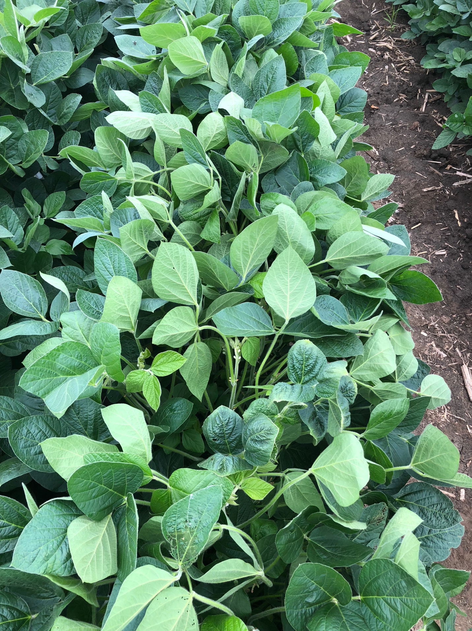

University of Wisconsin-Madison Weed Science

**XtendiMax w/Vaporgrip + Warrant + PowerMax**

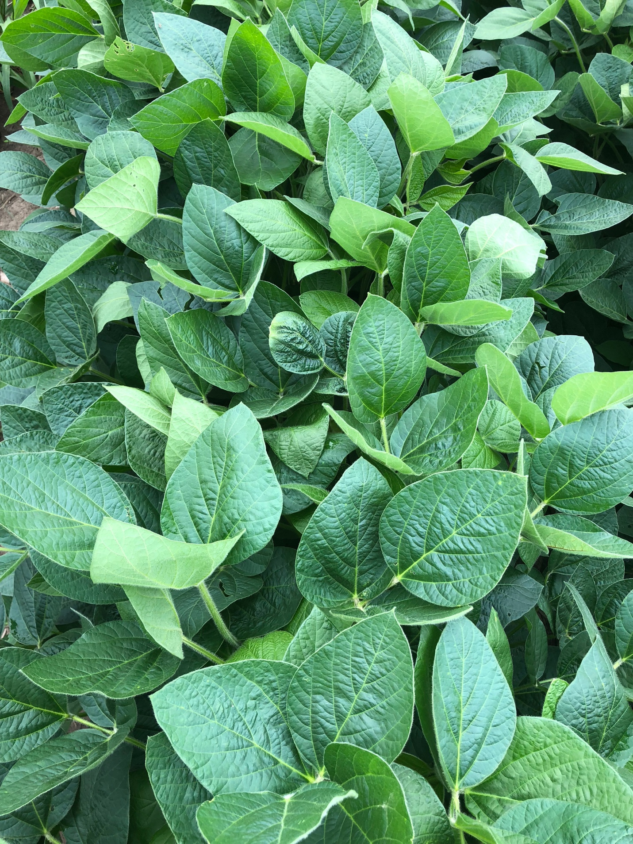

University of Wisconsin-Madison Weed Science

**Mon 304940**

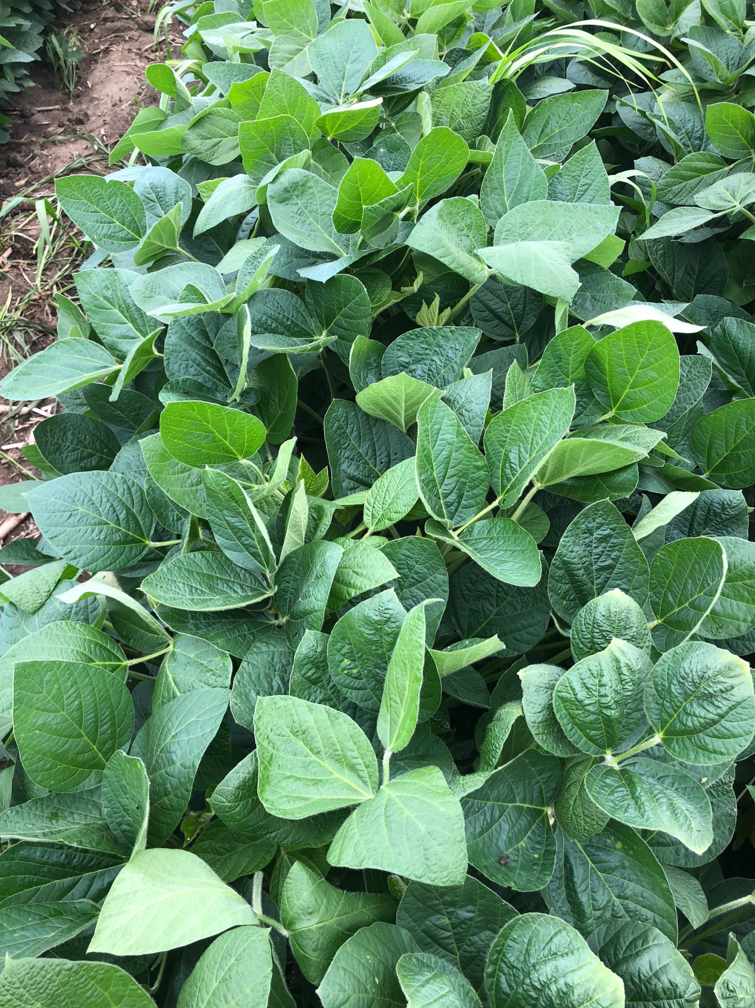

University of Wisconsin-Madison Weed Science

**Mon 304940 + PowerMax**

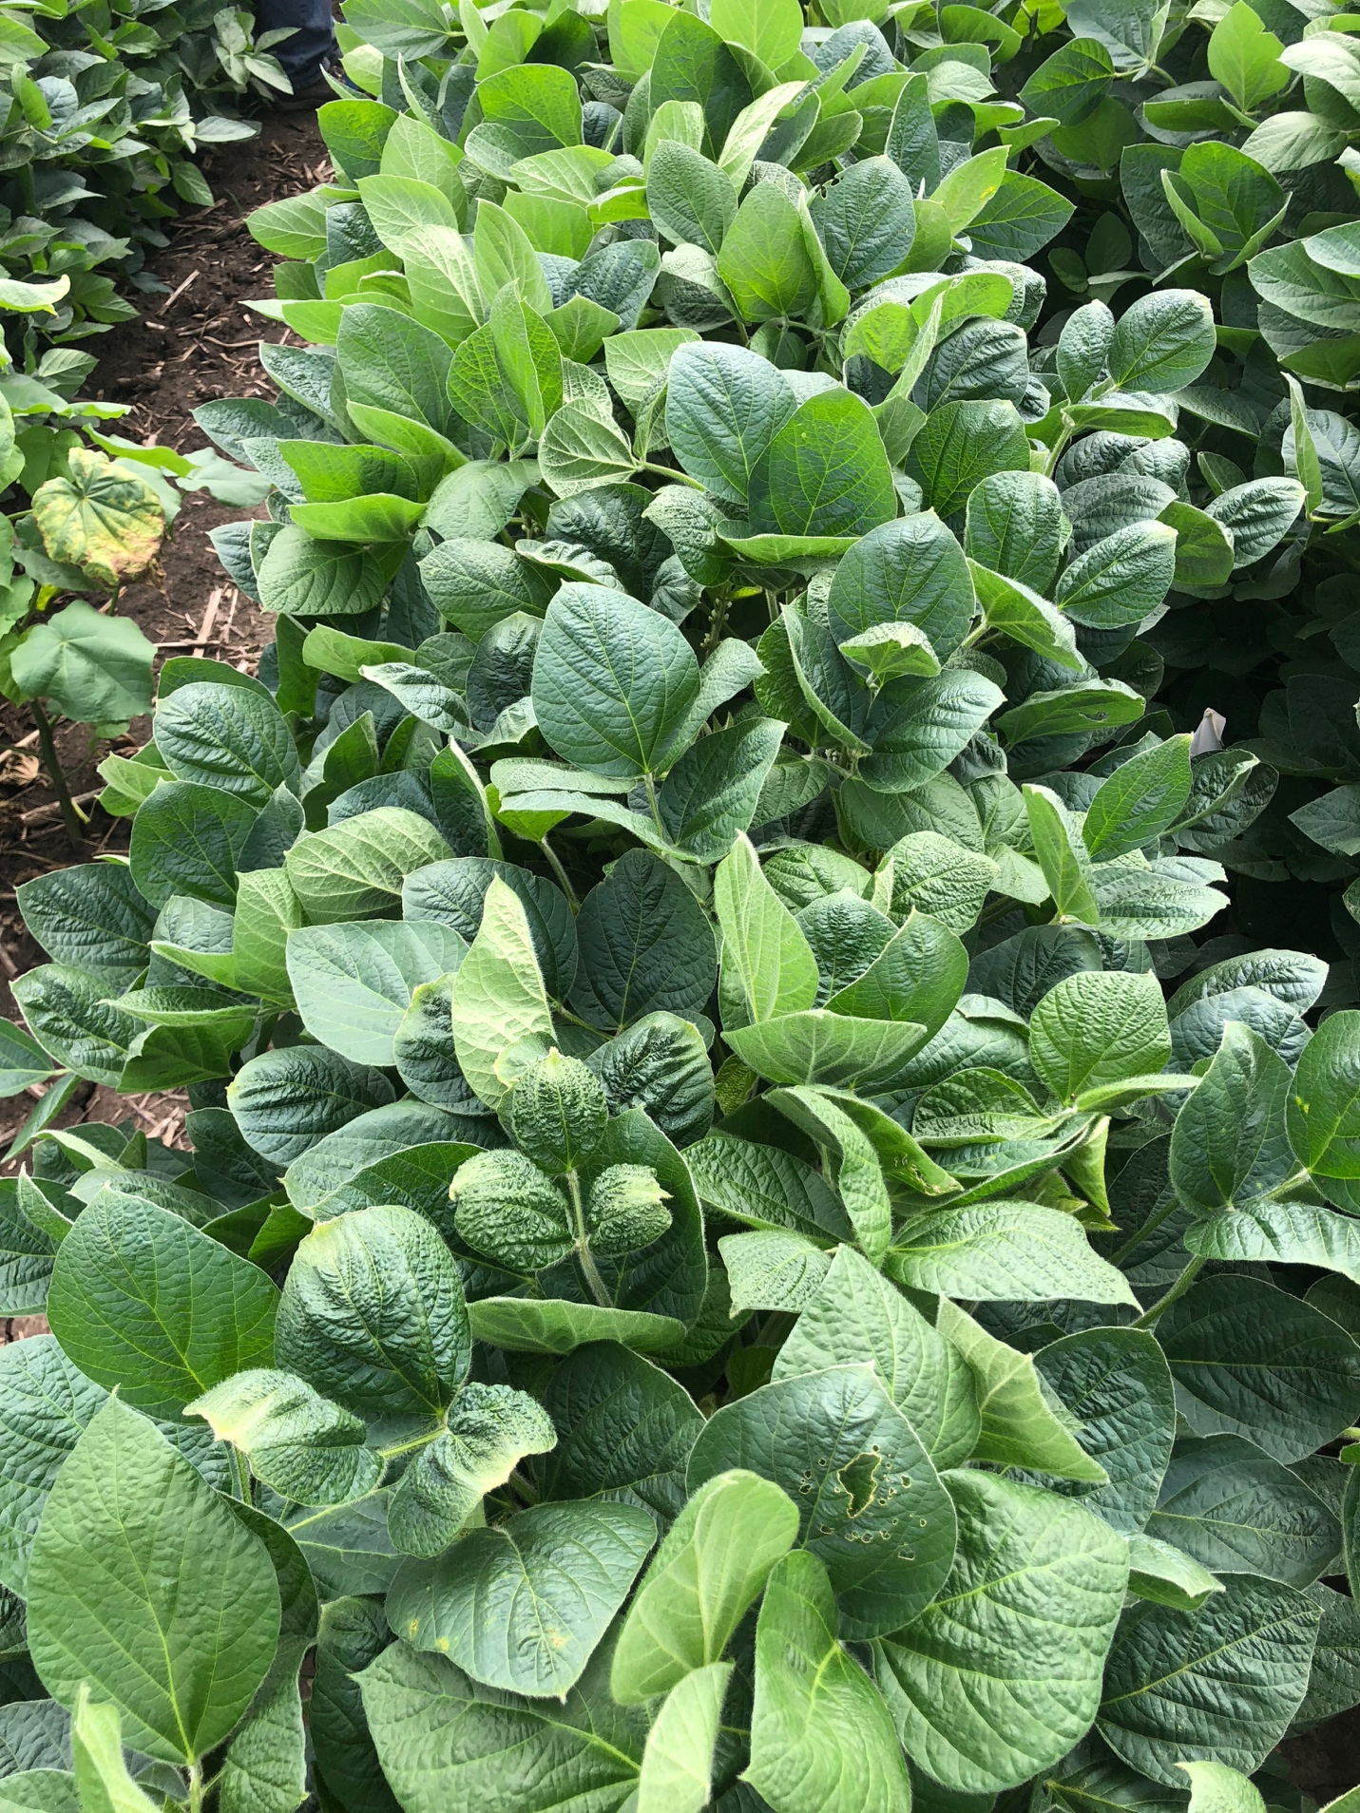

University of Wisconsin-Madison Weed Science

**Mon 301372**



University of Wisconsin-Madison Weed Science

**Mon 301372 + PowerMax**

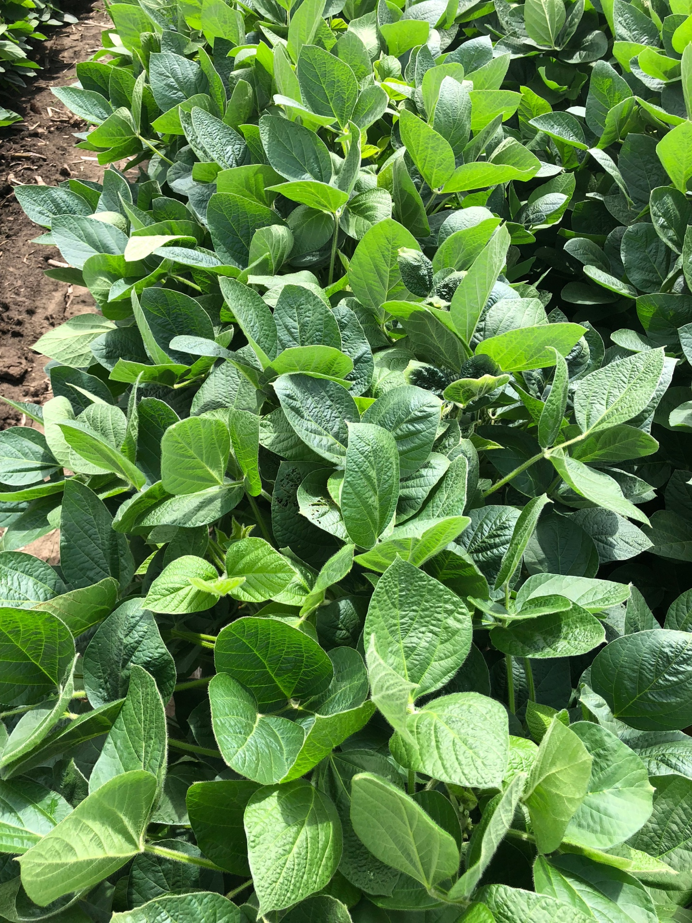

University of Wisconsin-Madison Weed Science

**Untreated**

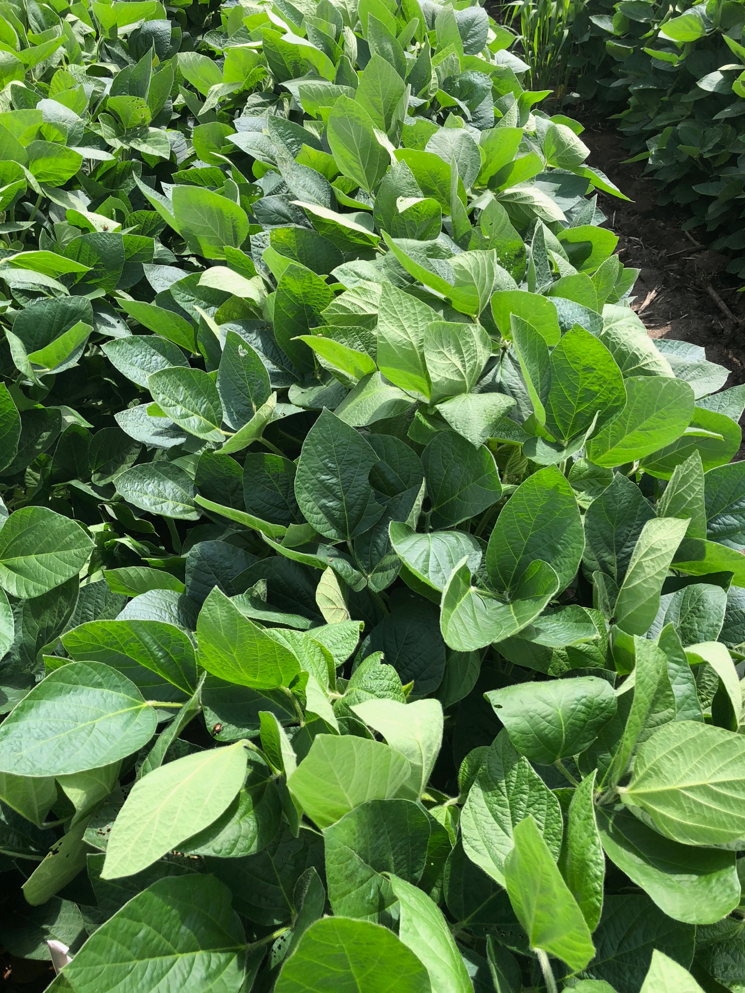

University of Wisconsin-Madison Weed Science